NAMI GRAND RAPIDS AREA  Presents  Corey Medina  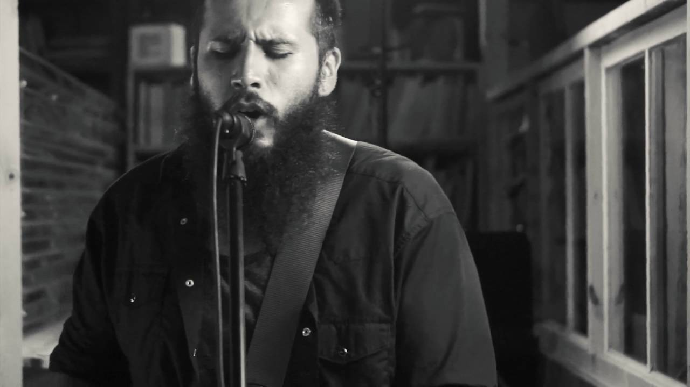  ‘Shedding a little light with the blues’  FREE event at the Reif Center  Tuesday, October 8th, 2019 7:30  Sponsored by NAMI in honor of Mental Illness Awareness week.  Corey Medina was born and raised in the small town of Shiprock, New Mexico, on the Navajo Reservation, where he developed his particular brand of blues. At age 12, Corey picked up the guitar, discovering blues riffs and scales that fueled his fire for music. Growing up with a single mom and a rebellious heart, Corey quickly learned what the "blues" was and meant. He heard not only the passion in the blues, but the hurt as well. His music, he says, aims at spreading a message of hope and encouragement to every tribe and tongue that has felt hopeless and held back in life by fear, shame and hurt. | 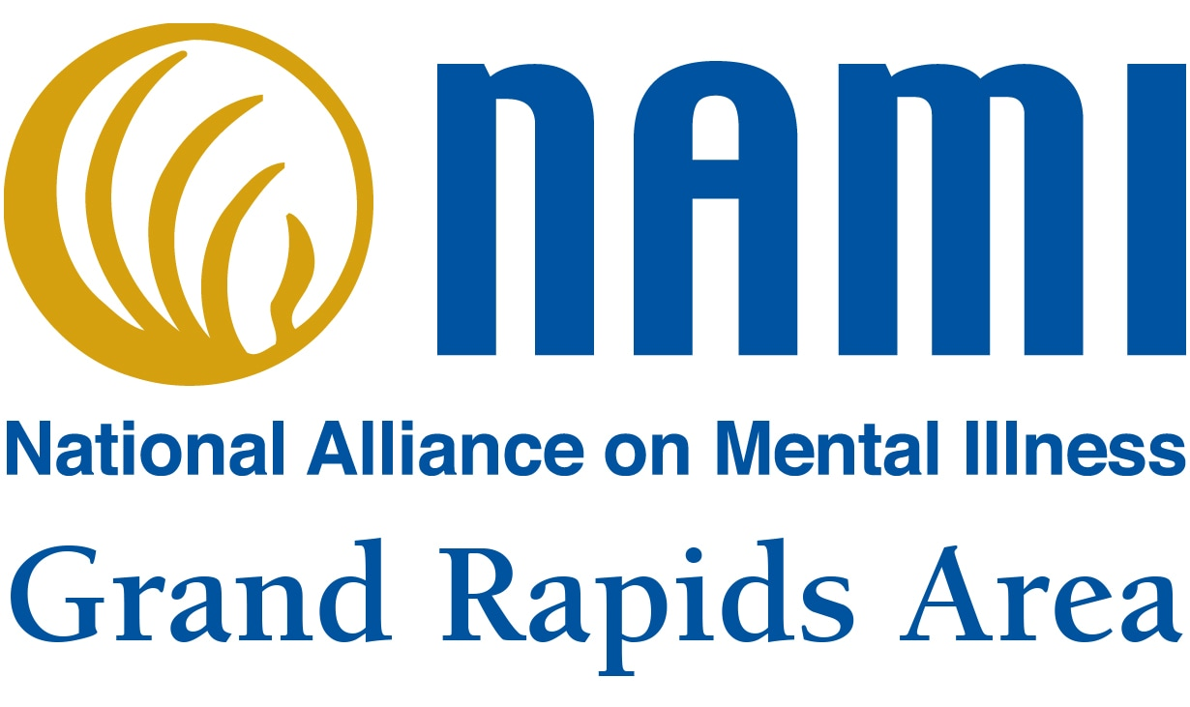

NAMI Grand Rapids Area
218-999-7658
namigrandrapidsmn.org
TEDX Talk-HERE

