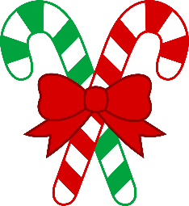
Make a difficult time a little
easier this holiday season by
donating to the NAMI-Grand Rapids Area
Holiday Gift Drive
November 28 – December 16
Mon. – Sat. 10:00-5:00
MacRostie Art Center

Sadly, many individuals hospitalized for mental illnesses do not get visitors or gifts, even over the holidays. Help us make the season a little brighter for those hospitalized at Fairview University Medical Center-Mesabi in Hibbing (34 patients).

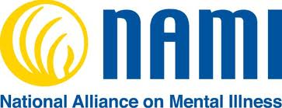
Gifts must be new, unwrapped and safe (nothing sharp or breakable, no ribbons or strings). Good ideas include: art materials, games, puzzles, air dry clay, DVDs, origami paper, journals (non-spiral), stationary, scrapbooking supplies, crossword puzzles and word finds, Sudoku, books, magazines, cards, cookbooks, small denomination gift cards (bus fares, groceries, home goods), stress ball, stocking hats, scarves, gloves, nice soaps, toiletries (toothbrush, shampoo, deodorant, lotion, body wash), calendars, microwave popcorn, etc.
Thank you! www.namigrandrapidsmn.org

