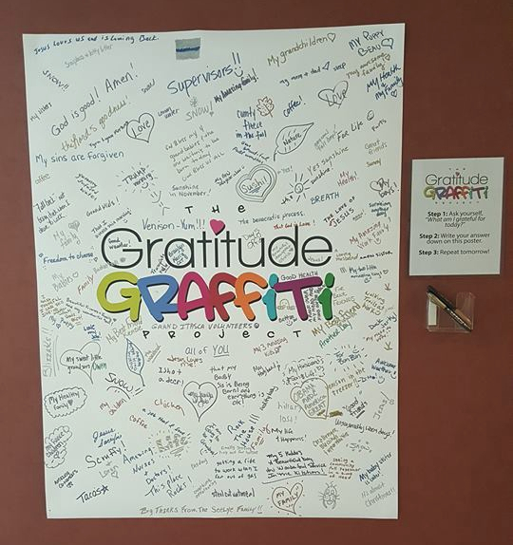
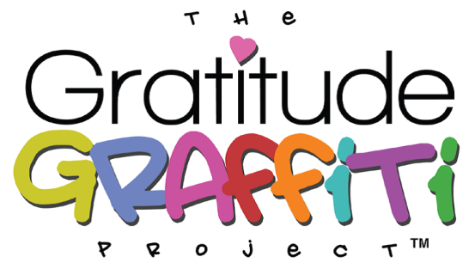
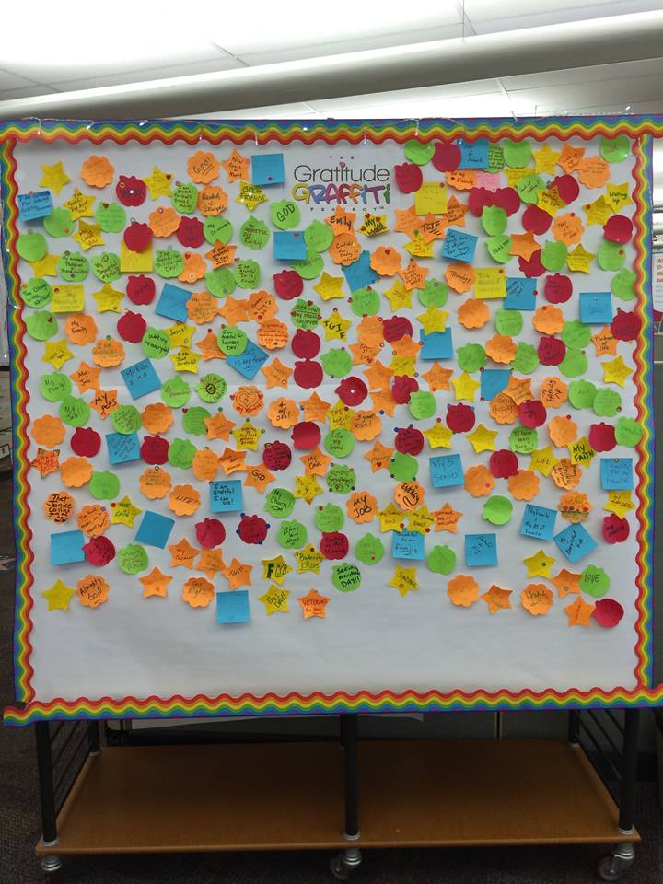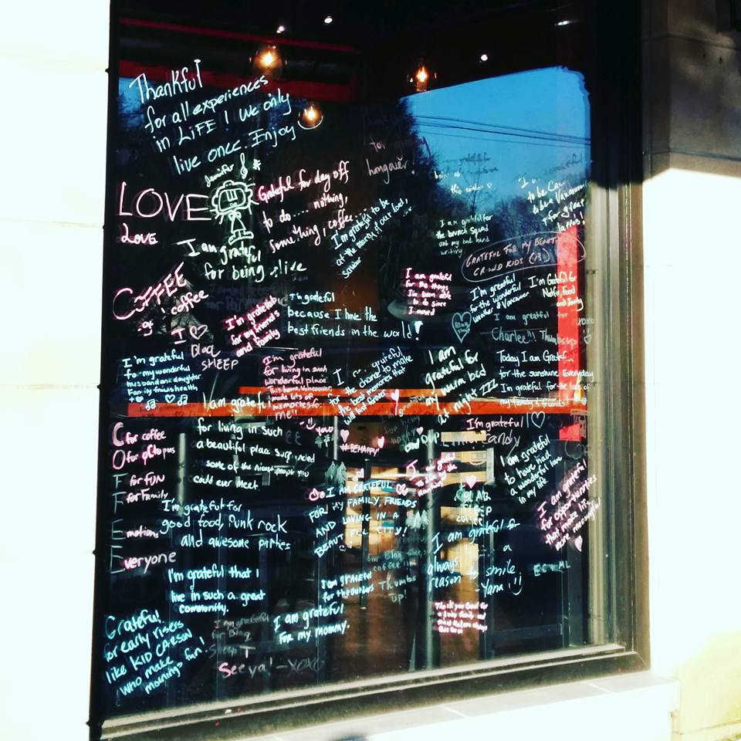
What is Gratitude Graffiti? Gratitude Graffiti is the daily practice of contemplating what one is grateful for in their life, then expressing that thought through interactive art in a public setting. Studies have shown that practicing gratitude has lasting positive effects on your health: helps to lower blood pressure, reduces stress, improves quality of sleep, increases resiliency, boosts your immune system and increases your energy and mental wellbeing. It has also shown to increase community connectedness by helping people to feel more connected in their community.
Please join us the month of November as we promote engaging our community in creating the art that expresses their gratitude!
If you would like to participate in the gratitude graffiti project, please contact: Nicole Edwards, Itasca County Public Health at: 218-327-6143 or email at Nicole.edwards@co.itasca.mn

