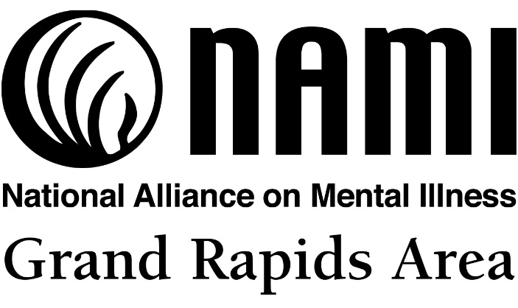

Make a difficult time a little easier this holiday season by donating to the NAMI-Grand Rapids Area
Holiday Gift Drive
November 23 – December 10
MacRostie Art Center & Kiesler Wellness Center (behind Walmart)

Sadly, many individuals hospitalized for mental illnesses do not get visitors or gifts, even over the holidays. Help us make the season a little brighter for those hospitalized at Fairview University Medical Center-Mesabi in Hibbing (34 patients).

Gifts must be new, unwrapped and safe (nothing sharp or breakable, no ribbons or strings). Ideas include: stamps, art materials, games, puzzles, air dry clay, DVDs, origami paper, journals (non-spiral), stationary, scrapbooking supplies, crossword puzzles and word finds, Sudoku, books, magazines, cards, cookbooks, small denomination gift cards (bus fares, groceries, home goods), stress ball, scarves, gloves, t-shirts, nice soaps, toiletries (toothbrush, toothpaste, shampoo, deodorant, lotion, body wash), calendars, microwave popcorn, gum, etc.

Thank you! www.namigrandrapidsmn.org

