Mental Health Providers:
Anderson Jore Counseling: 218-326-9781
Renee Jore Anderson, MS, LMFT, LADC
Mark Anderson, LADC
Victoria Beck, LICSW M

Bradley R. Nelson: 218-326-0783
Provides individual counseling, assessment,
Evaluation and education.

Children’s Behavioral Health Services:
218-326-999-9690 M

Children’s Mental Health Services:
218-327-4886
Lynette Schmidt MSW, LICSW M
Beth Prewett PsyD, LPCC
Dr. William Larsen, PhD, LP
Jessie Perkavich, MS LPCC
Tasha Connelly, MA, MFT
Michael Harbin, MSW, LGSW
Kelsey Unger, MS LPCC
Jollene Latvala, MSW, LGSW
Melissa Weidendorf, MS
Jenny Farber, MSW, LGSW
Kathy Field-Tabaka, MSW, LICSW

Compass Behavioral Health: 218-999-7750
Alex Meyer LGSW, LACD
Office within Modern M.O.j.O
Offers psychiatry, medication management, medication therapy and counseling, tele-psychiatry, genetic testing, behavioral counseling, addiction counseling, mental health assessment, chemical health assessment.

Essentia Health – Deer River: 218-246-8275
Tele-Psych for current patients

Heather Rhodes, MS, LP: 218-327-0887
Psychologist providing services including dealing with anxiety, panic, stress, depression, grief and loss, and chronic pain.
Janine Hill, MS, LMFT: 218-999-7552
Trained in Trauma Treatment Psychological Services LLC.

Lakeview Behavioral Health: 218-302-4468
Psychiatric consultations, med management, and tele-psychiatry. Ages 12+
Philip Valdez, Psy.D., LMFT, LADC
Ann Olsen, BS, LADC
Karl Olsen, LADC, ADC-MN
Dawna Mclaughlin, LADC
Thomas Johnson, CNP
Elizabeth Erickson, LADC
Louise Dewey, APRN, PMHNP-BC
Dana Butler, LMFT
Lisa Bildeaux, therapist intern
Maria Asplund, LADC intern
Lakeview Behavioral South location (Rapids Counseling): 218-327-2001 Alcohol and drug counseling.

Lisa Adamich, MS, LICSW: 218-259-9417
Works with individuals and family therapy.

Loie Meyer, MA, LMFT: 218-327-7267
Marriage and family therapy.

Mary Linnihan, LP: 218-244-9414
Psychologist dealing with adults and adolescents with anxiety, depression, grief, EMDR, and relationship issues.

Modern M.O.j.O: 218-999-7750
Tracy Zimmerman-Deschepper, APRN
Medication management, therapy, and testing services. M

Northland Counseling Center: 218-326-1274
Jennifer Alstad, MS. ED., LMFT
Angie Baratto, MA, LPCC
Jim Christian, MA, LAMFT
Lauren Flood, MA, MFT
Jean Heitzman, MSW, LICSW - M
(Office located at Kiesler Wellness Center 326-5114)
Ana Pereira, MA, LMFT
Linh Scally, MSW, LGSW
John White, MA, LMFT
Brandi Worrath, MS, LPCC
Thomas Kafalas, MD
Marla Fix, MSW, LGSW
Brian Navratil, MS, LAMFT
NCC continued…
Tabbatha Litchke, MS, ED
Kirstiane Bilyeu, MSW, LGSW
Brea Wallaker, MSW, LGSW
Laura Larsen, MSW, LGSW
Kayla Meyer, MS
Mandi Shimek, MA, LPCC
Lisa Fox, MA
Angela Pellerito, MS, RN, PMHNP M

North Homes Mental Health Clinic: 218-327-3000
Becky Zidarich, MA
Dr. Donnie Farnsworth, PH.D, LP M
Dr. Lindsay Kujawa PH.D
Jennifer Kliewer, MSW, LGSW
Jennifer Moreland, MS, LAMFT
Lisa Corradi, MSW, LICSW
Colbi Ikola, MS
Colin Heglund, MA, LP
Eric Nance, MSW, LICSW
Jonathan Friedt, MA, LMFT
Kathy Faver, MSW, LICSW
Kirsten Craft, MA, LPC
Nicole Brenny, MS, LPC
Richard William Faver, MA, LP
Sarah Baker, MSW, LICSW
Susan Kramer, MS, LPCC

Pamela Johnson LP: 218-327-9336
Psychologist dealing with adults, families, and children.

Providence Psychiatry Services: 218-246-6286
Jean Vaneps, CNP
Family psychiatric, specializes in psychiatric disorders including: depression, anxiety, bipolar disorder, schizophrenia, OCD, PTSD, ADHD, autism, ODD, etc. Ages 5+

Stapleton Psychological Services: 218-326-5694
Kenneth Stapleton LP
Providing individual, adult and kids 13+ counseling.

Stenlund Psychological Services: 218-327-8937
Bryan Stenlund MS, LP
Jeff Olds, MSW, LICSW
Valerie Hawkinson LGSW
Laura Nikkel MS
Providing services for adults, children, blended families, chemical dependency issues, ADHD, marital stress management, depression and anxiety, pain management, and anger management services. 3 case managers are also on staff

Toonstra Psychological Services: 218-259-7424
Psychologist with emphasis on evaluation/testing services as well as individual, family, and couples counseling services.

Thomas Counseling and Wellness Center, LLC: 218-360-5503
Michelle Rinne, MS Ed., Psychologist
Cindy Lee Thomas MSW M

Out of Area Providers:
Range Mental Health: ARMHS, Case Management, Psychologists, Psychiatrists, Counseling Services
Hibbing Office: 800-450-2273 or 218-262-3107
Virginia Office: 800-450-2273

Mental Health Services: Lakeland Psychiatry Clinic: (St. Joseph’s Medical Center-Brainerd) 218-828-7394

Other Mental Health:
Adult Rehabilitative Mental Health Services –ARMHS

NHS – Northstar Specialized Services: 218-447-7160
Located at 501 S. Pokegama Ave, Grand Rapids.

Northland Counseling Center: 218-326-1274 or
1-800-450-1274

Nystrom and Associates: (Brainerd) 218-829-9307

Adolescent Targeted Case Management–
Ross Resources: 326-6434

Children’s Mental Health: 327-4886 ext. 110

North Homes: 327-3000

Adult Targeted Case Management-
Stenlund Psychological Services– 327-8937

Northland Counseling Center– 326-1274

North Homes– 999-9908

Developmentally Disabled Targeted Case Management-
Itasca County Social Services: 327-2941
Nystrom & Associates (Brainerd/Baxter),: 218-829-9307

Lakeland Psychiatry Clinic: (St. Joseph’s Medical Center Brainerd)
218-828-7394

Lisa Riggs CNP: 218-999-9832
Ages 13+ M
Stepping Stones Child and Family Services LLC:
Kelly Chandler – 218-301-9122
Trauma Certified Providers:
https://tfcbt.org/members/
North Homes Mental Health Clinic: 218-999-9908
Jennifer Sheppard, MSW, LICSW M
Katie Rubesh, MSW, LICSW M not taking new clients
Amy Mallum, MSW, LICSW M

Medical Providers:
Bigfork Valley 218-743-3177

Essentia-Deer River 218-246-8275

Grand Itasca Clinic 218-326-7344

Grand Itasca Hospital 218-326-3401

Meridian Medical Clinic-Grand Rapids 218-999-7000

Fairview Mesaba Clinic-Nashwauk 218-885-2858

Partial Hospitalization Program:
Fairview Range Medical Center: 218-362-6672
Intensive day treatment for clients that don’t meet hospitalization but are not safe to be at home during the day.
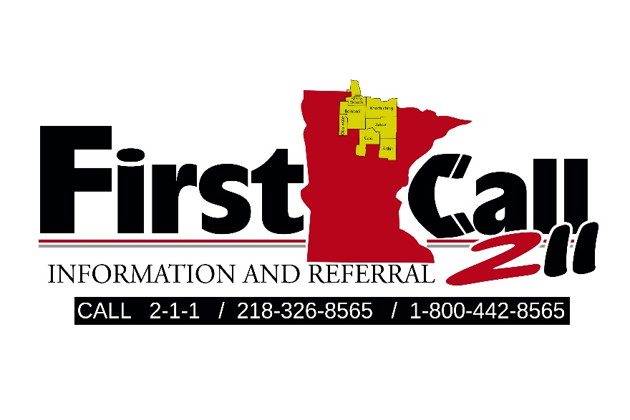

Itasca County Mental Health Providers
Resource Guide

Updated 3/14/2018 M – Medicare

